# Programming Basic Applications

## Linux/CLI Method

**Note**: In the following sections, we continue with Linux and CLI method of creating applications. However, you can also choose to use Eclipse as your development environment.

### Hello-World Application

**Note**: This section is recommended for Linux/Windows users familiar with command line tools. The assumption is that the users use their own text editor.

In this first example, we begin by creating a very simple application that outputs a string "hello world." to the console. The application shall be located inside a folder that holds all the applications in the SDK folder tree (i.e., *freertos_sdk\apps*).

**Note**: Only create a new folder or a file if it does not exist already.

1. To begin with, create a folder called helloworld inside apps directory (i.e., \apps\helloworld).
2. Create a file called my_app.c inside the folder *\apps\helloworld* using any text editor (my_app.c will be under *apps\helloworld\my_app.c*).
3. Copy/paste the following piece of code to my_app.c file.

|  |
| --- |
| #include <kernel/io.h>  #include <kernel/debug.h>  int main()  {  os_printf("Hello World.\n");  return 0;  } |

Just like in any C program, we declare the function int main () which is the first point of entry into our application. Then we call an OS dependent function, os_printf() to output the string on the console. Finally, we call return which in this case returns a zero.

#### Makefiles - Compiling Applications for Non-Eclipse Users Only

To compile our applications, we use the SDK libraries that provide all function calls necessary.

1. Using a text editor of your choice (and *inside\apps*), create a file called Makefile (i.e., *apps\Makefile*). If the file Makefile already exists, edit it [ONLY] by adding your own entry as shown in Figure 1.

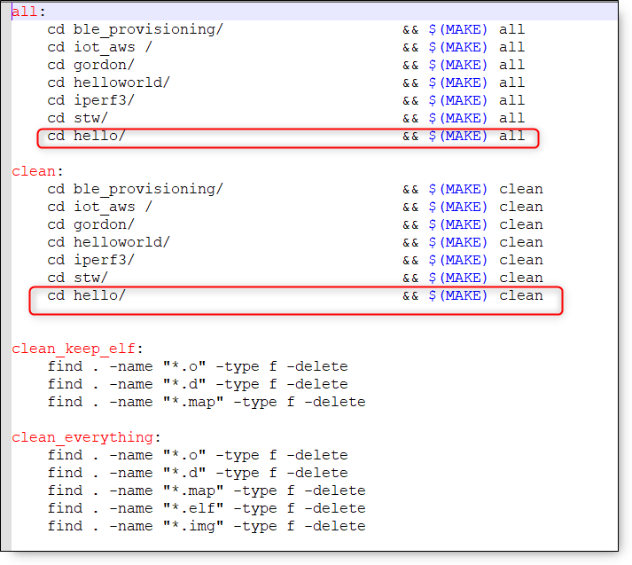

Figure 1: Editing the Makefile

**Note**: For Windows OS users navigate till SDK conf folder, open file sdk.mak and find ${LIBGCC} in the line DEFAULTLIBS = -lkernel -lc ${LIBGCC} and replace it ${LIBGCC}, i.e., DEFAULTLIBS = -lkernel -lc ${LIBGCC}.

1. Create another Makefile which will help compile the application we just wrote.

|  |
| --- |
| #Makefile for compiling applications into Talaria (TM) TWO  include ../../conf/sdk.mak  HELLO_APPS=../helloworld  all: helloworld.elf  #HELLO  helloworld.elf: $(HELLO_APPS)/ my_app.o _app_start.S |

The code above is the Makefile for my_app.c (i.e., *apps\helloworld\Makefile*). The first line in this Makefile is just a comment (i.e., all lines inside a Makefile beginning with # are comments). The line, *include ../conf/sdk.mak* includes the file sdk.mak which specifies all the rules on how our binary file is obtained. The variable HELLO_APPS is the path where our application file is located. We also define a rule as all: helloworld.elf and this tells us, that when we invoke make, which binary file(s) will be generated.

The line *$(HELLO_APPS)\my_app.o* _app_start.o tells us that the file helloworld.elf, depends on object file(s) declared in HELLO_APPS. The file _app_start.o, defines how our application starts (alternatively, copy _app_start.S directly into your *apps\helloworld* directory).

1. After creating Makefile inside the current directory (i.e., *apps\helloworld*), run make or make -j4. Invoking make will compile your application and place a file called helloworld.elf into the *apps\helloworld* directory. This helloworld.elf (firmware file) will be used to flash the Talaria TWO device as shown in the section: *Downloading Firmware to the Talaria TWO for Test & Evaluation*.

## Programmer Tool

Program the helloworld.elf from sdk_x.y\apps\helloworld\bin using the Download tool(sdk_x.y\pc_tools\Download_Tool\bin) provided with InnoPhase Talaria TWO SDK.

Launch the Download tool and configure the following in the GUI window:

1. Boot Target: Select the appropriate EVK from the drop-down
2. ELF Input: Load the helloworld.elf by clicking on Select ELF File.
3. Programming: Click PROG Flash to Program Talaria TWO with helloworld.elf

**Note**: x and y refer to the SDK release version. For example: sdk_2.6\doc.

Console output

|  |
| --- |
| UART:SNWWWWAE  Build $Id: git-7a1d5fcb8 $  hio.baudrate=921600  flash: Gordon ready!  Y-BOOT 208ef13 2019-07-22 12:26:54 -0500 790da1-b-7  ROM yoda-h0-rom-16-0-gd5a8e586  FLASH:PNWWWAEBuild $Id: git-7a1d5fcb8 $  Hello World |